Protect Our Pollinators

Overview: This fun game can be used to reinforce pupils’ understanding of the role that insect pollinators play in the reproduction process of flowering plants. It is also an excellent way to introduce the idea that environmental threats to insect pollinators can have a significant impact on food security. Although this game requires a number of resources, most of the things that you need are easily obtainable and it is definitely worth it! This pollination game is popular with young people and can be used again and again!

Who: KS3

How long: 1 hour

Curriculum links
We have designed this lesson to help teachers cover the following areas of the KS3 Science curriculum:

Biology- Structure and Function of Living Organisms
Reproduction
- Reproduction in plants, including flower structure, wind and insect pollination, fertilisation, seed and fruit formation and dispersal, including quantitative investigation of some dispersal mechanisms.

Biology- Interactions and Interdependencies
Relationships in an eco-system
- The interdependence of organisms in an ecosystem, including food webs and insect pollinated crops.
- The importance of plant reproduction through insect pollination in human food security.
- How organisms affect, and are affected by, their environment, including the accumulation of toxic materials.

The lesson enables students to:
- Make links between plants and the insect pollinators they rely upon in order to reproduce,
- Model the process of insect pollination and the impact that pesticides can have on that process.
- Put the importance of insect pollination of crops into context with our own food security.
- Discuss how they can help to look after insect pollinators around their school.

Resources
- Protect Our Pollinators- PowerPoint for the session
- A3 printout of Parts of a Flower Activity Sheet
- Sticky notes
- Protecting Pollinators action cards.

For the main activity, you will need:
- 4 x plastic pint pots with ‘pollen’ written on them.
- 4 x plastic pint pots of coloured water with ‘nectar’ written on them.
- Water
- Food colouring (red)
- A class set of pipettes.
- 4 plain plastic pint pots
- 4 x laminated pictures of an apple tree (see downloads)
- 4 x laminated pictures of stamen (see downloads)
- 4 x Laminated pictures of carpels (see downloads)
- A class set of small receptacles such as falcon tubes/ plastic test tubes
- 4 x measuring cylinders
- 1 plastic funnel
- 2 x individual whiteboards/ sheets of paper with Round 1 and Round 2 written on them.
- Plenty of counters to represent pollen.
- Pesticide cards (see downloads)
Pre-lesson prep:
- Choose an appropriate space for the Main Activity (The Pollination Game). This should be an open area such as the school hall, playground or a large classroom.
- Around the space, set up four ‘tree’ stations (see pictures below):

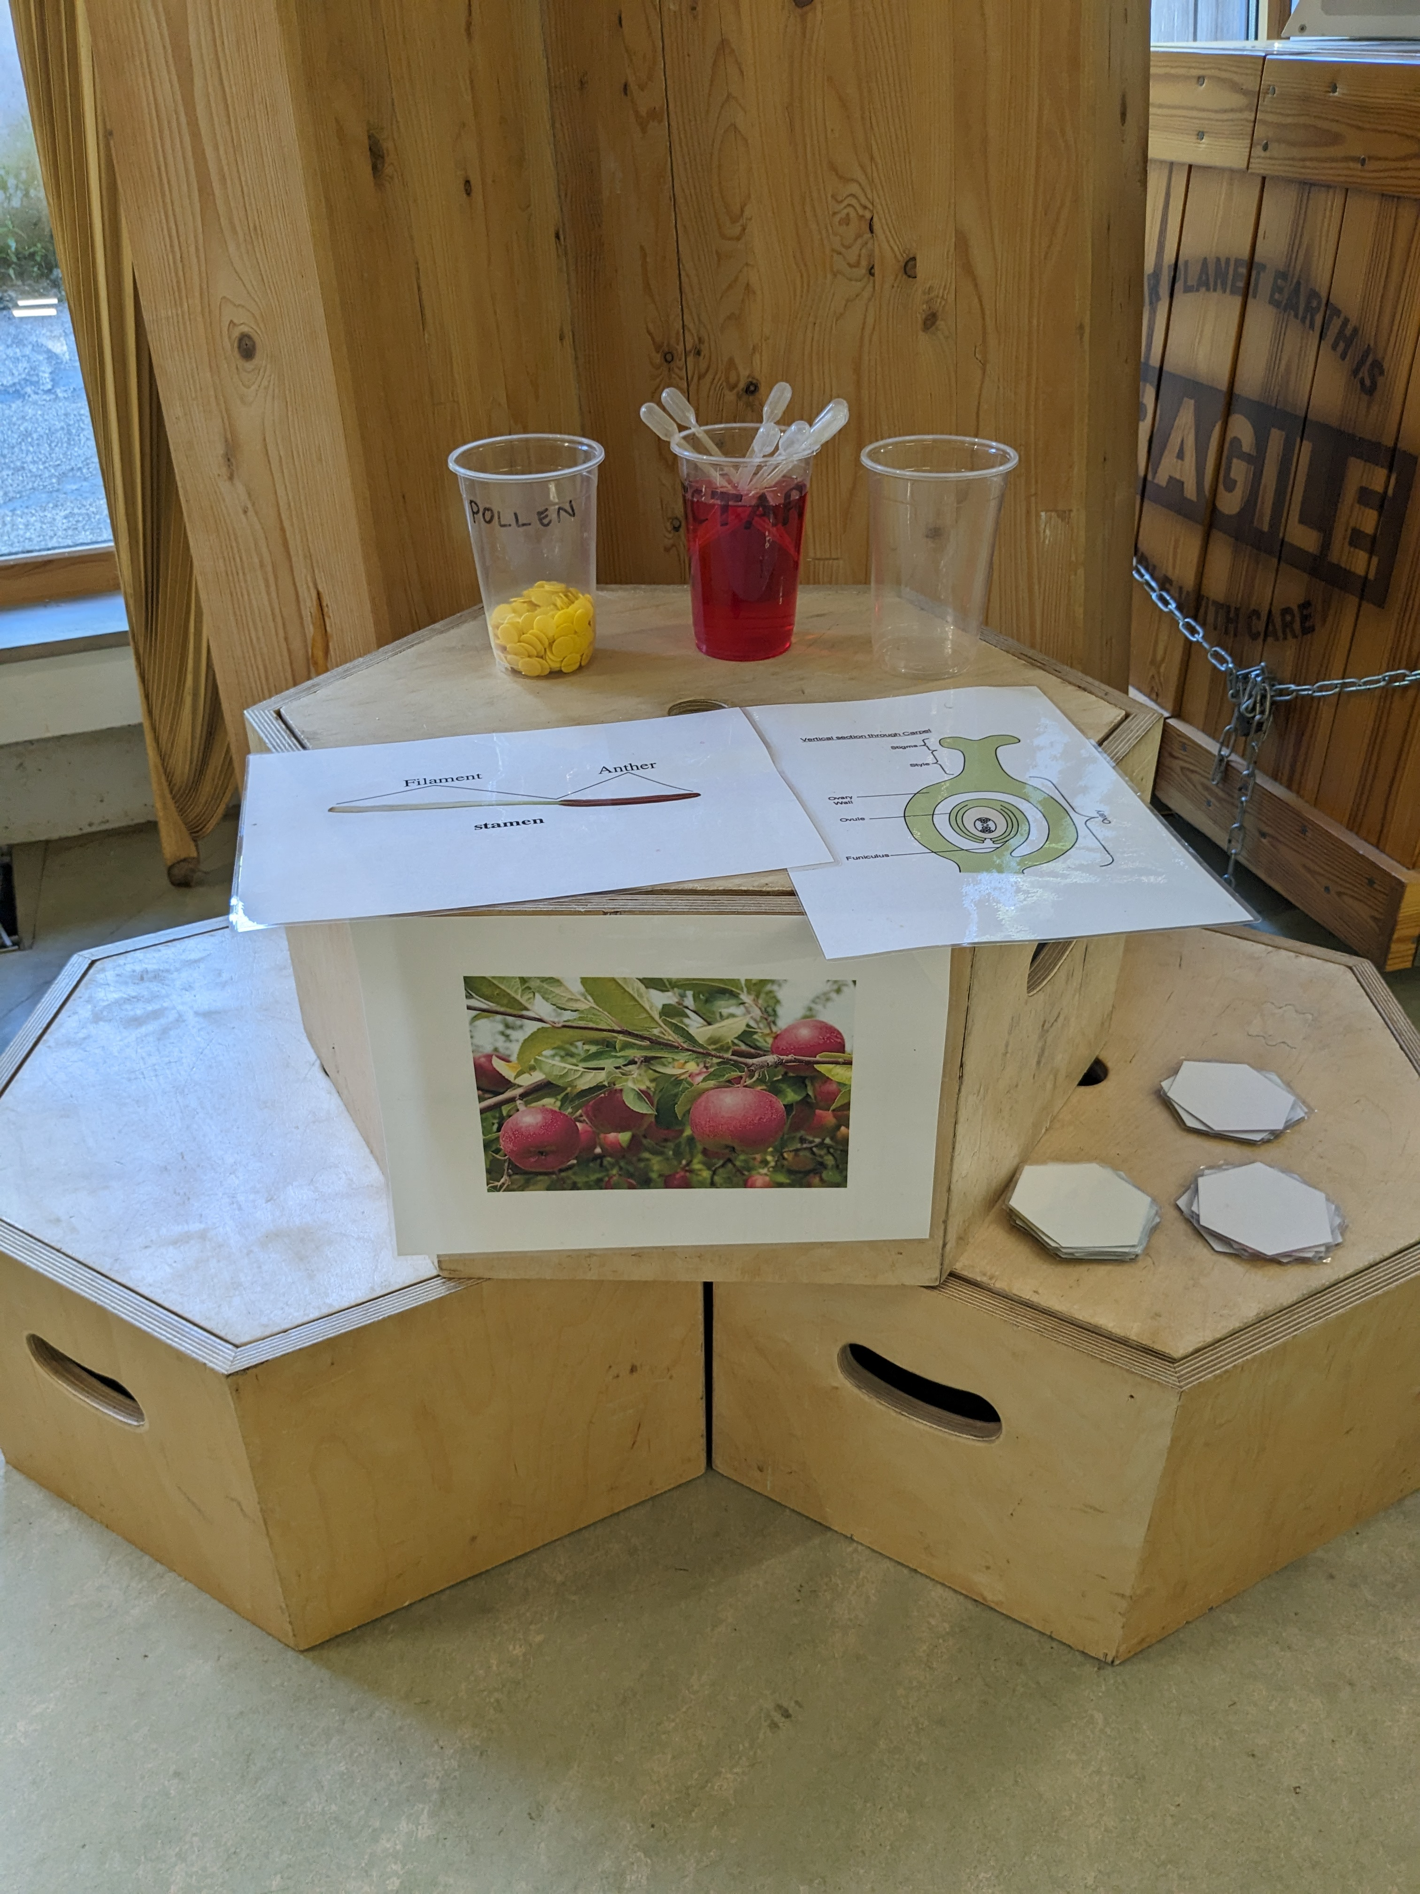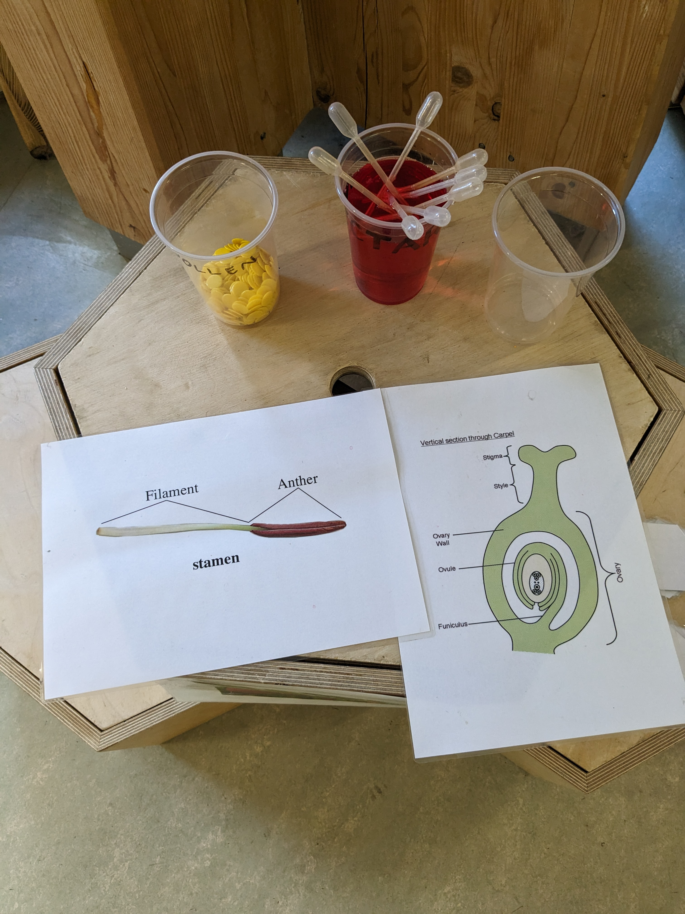

- Each station is represented by a laminated picture of an apple tree and needs to include:
- A plastic pint cup (with pollen written on it) filled approximately one third of the way up with counters (representing the pollen)- this should be sat on/ above a laminated picture of a stamen;
- A plastic pint cup (with nectar written on it) filled approximately half way with coloured water (representing the nectar), containing a few pipettes to allow pupils to collect the nectar;
- A laminated picture of a carpel with a plain/ empty plastic pint pot sitting on top of it (this is for pollen to be transferred into).
- At the front of the playing space, put two signs reading, ‘round 1’ and ‘round 2’. Each sign should have two measuring cylinders in front of it (to measure the collected nectar and transferred pollen at the end of each round) . It is also useful to have a funnel to make sure no nectar is spilt.
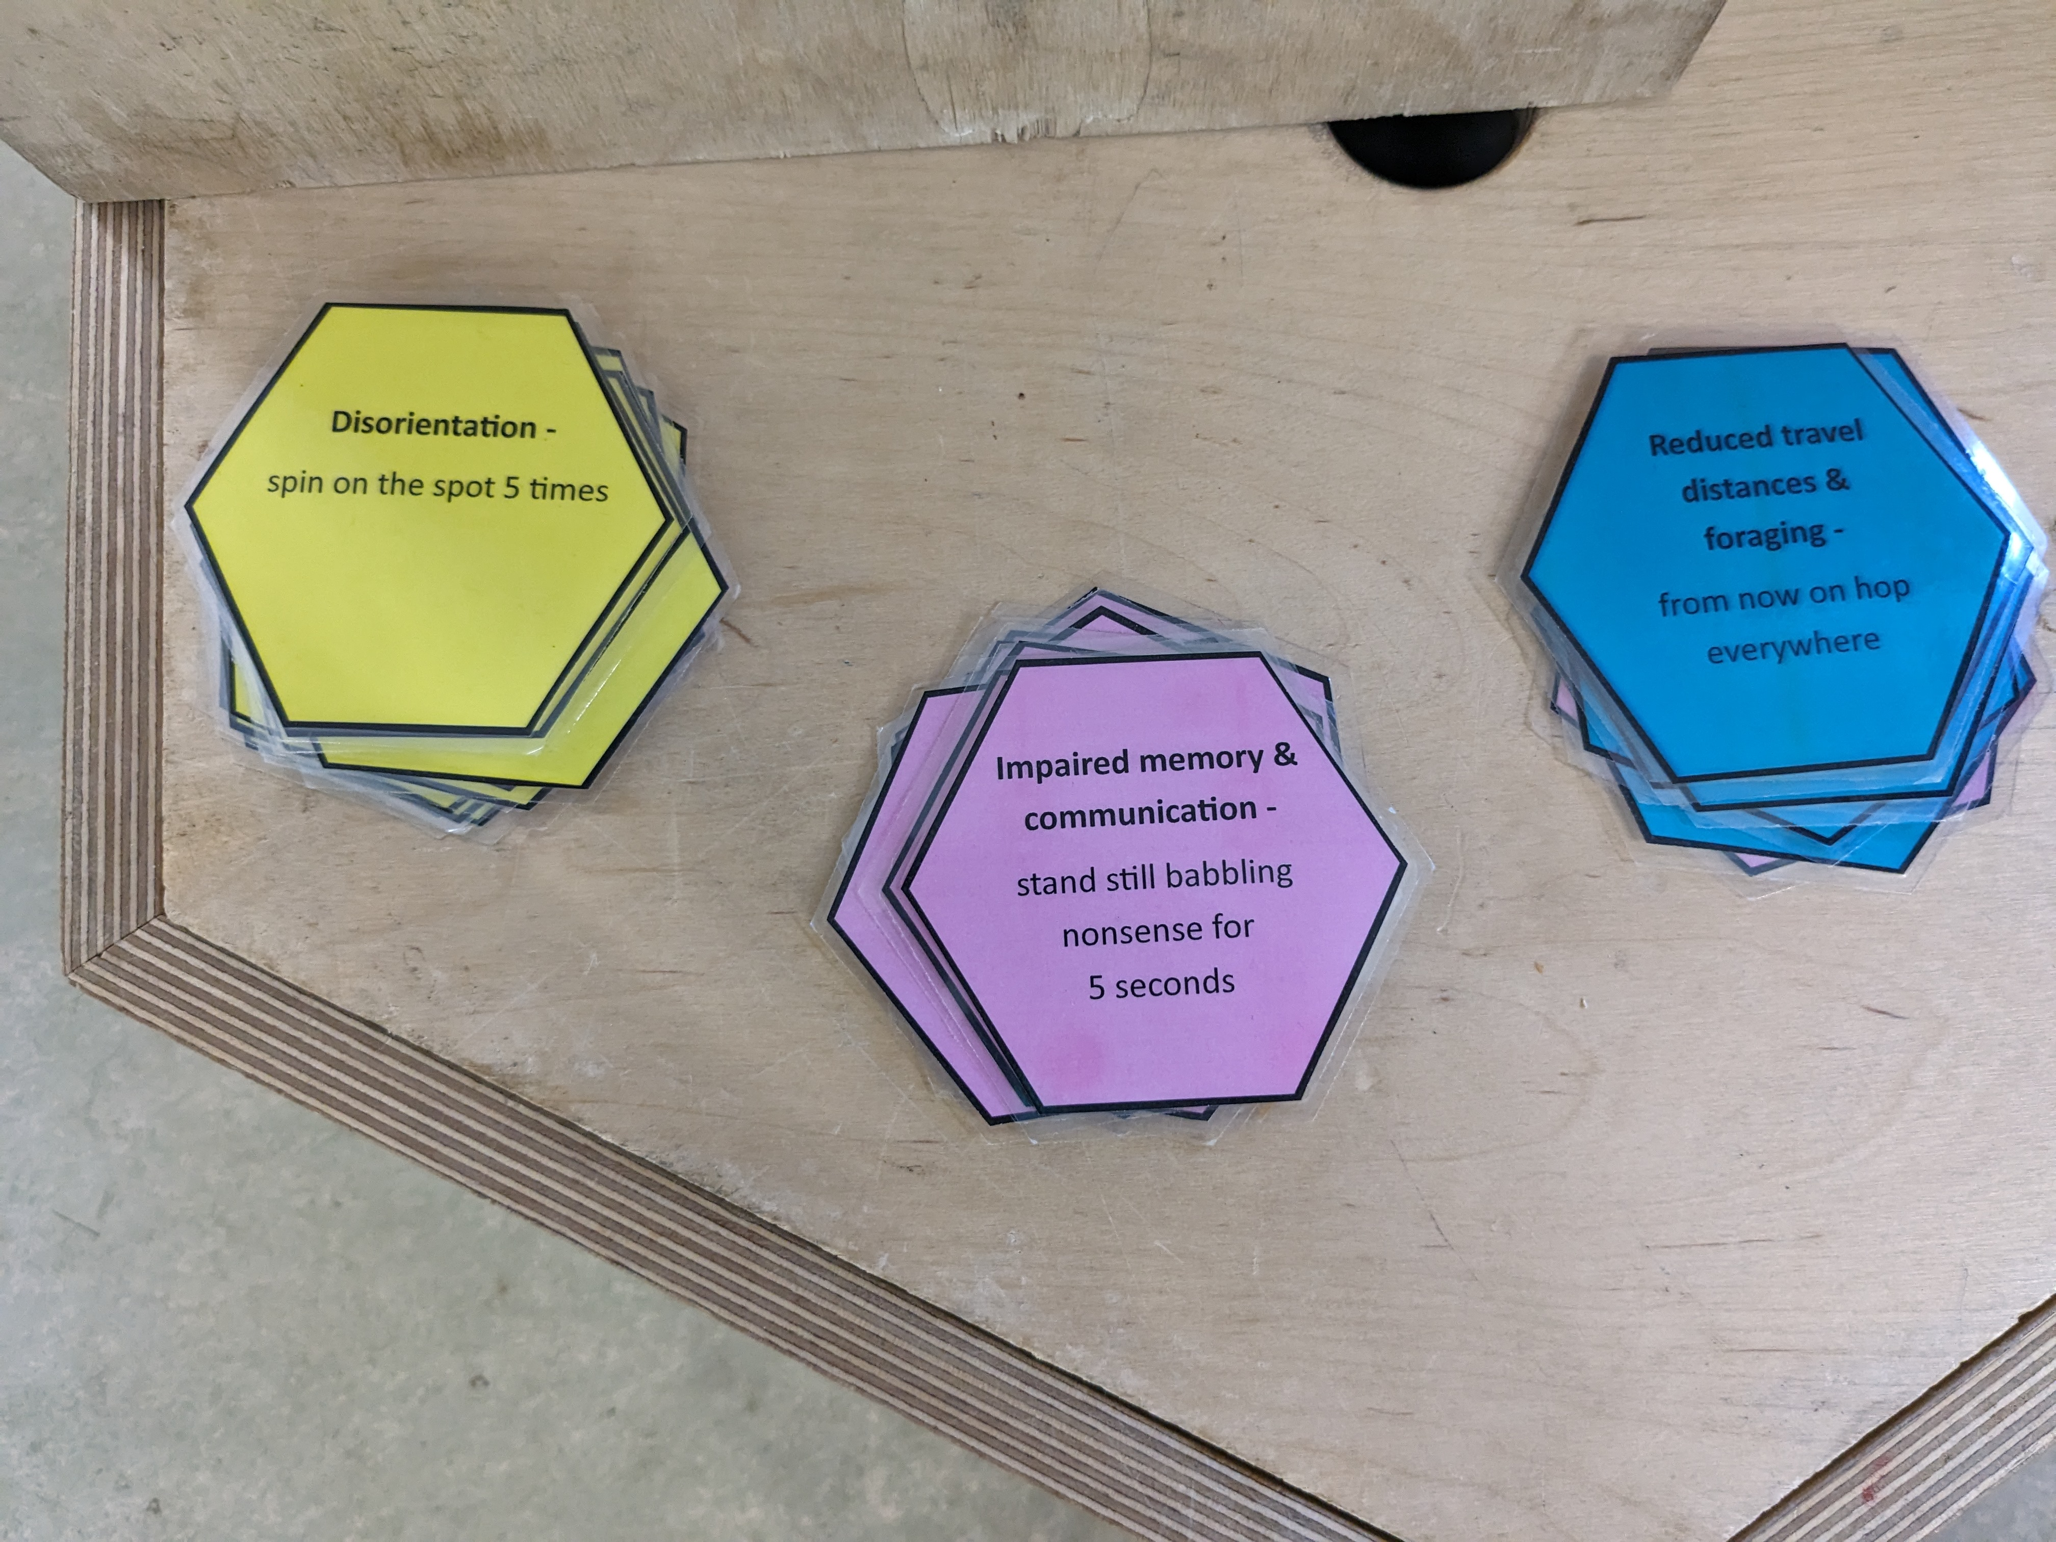
- In preparation for Round 2, you will also need to print and cut out the pesticide cards (see downloads):

Getting Started [15 minutes]
- Slide 2- Begin the session by revising the structure of a flower. Provide pairs/ small groups of pupils with an A3 printout of the ‘Parts of a Flower’ activity sheet (see downloads) and a set of 9 sticky notes. Display the names of the different parts of a flowering plant, from Slide 2, on the board. Ask pupils to write each of these names on its own sticky note along with anything else they know about that part of the plant – its function? what happens there?’. Having written the name and descriptions on all of their sticky notes, they should stick them in the appropriate place on their A3 printout.
- Review the activity, taking feedback from the class. Use this as an opportunity to assess their current level of understanding and address any misconceptions.
- Next, use the images from Slide 3 to explain the interdependency between flowering plants and insect pollinators.
Main Activity [20 minutes]
- Slide 4- Explain to pupils that they are going to play a game that models how pollinators collect nectar and move pollen from one flower to another- The Pollination Game:
- Provide each pupil with a receptacle to carry nectar around with them (such as a falcon tube) and explain how the game works:
- “Around the room there are 4 apple tree stations. You are insect pollinators and it is your job to collect nectar from each station and, in the process, pollinate each tree by moving pollen from the flower of one apple tree to the flower of another.”
- Explain that at each station they will find a plastic cup labelled nectar. This cup will be filled with red liquid (representing nectar). They should use the pipettes to collect one pipette full of nectar and put this in their receptacle (you may need to demonstrate how to use the pipette). They will then collect a single piece of pollen (a coloured counter) from the plastic cup that sits on top of the picture of an anther. They then move to another station, deposit their pollen in the plastic cup sitting on top of the picture of a stigma, before collecting more nectar-starting the process all over again. They have 3 minutes to visit as many flowers as they can.
- At the end of the 3 minutes the insect pollinators deposit all of the nectar that they have collected into the ‘round 1 measuring cylinder’ (using the funnel) and measure how many millilitres they collected. They should also empty all of the transferred pollen from around the room into another measuring cylinder to see how much pollination occurred.
- Having completed ‘round one’ of the game, use the news articles on Slide 5 to introduce the class to the idea that our insect pollinators are under threat and that this poses a threat to food security.
- Use the first part of the ‘Why we need insects’ video on Slide 6 to make sure pupils understand why insect pollinators are so important, what dangers they currently face and the causes of these dangers.
https://www.youtube.com/watch?v=6QwiYfqX1sg&t=215s
- Stop the video at 3 minutes 26 seconds. Explain to the pupils that not all pesticides kill insect pollinators out right (although some of them do), many of them harm insects by causing problems with their reproduction, navigation and memory. This is having a significant impact on their ability to pollinate and on fruit and crop production around the world.
- Slide 7- Explain that to demonstrate the effect that pesticides are having on some of our insect pollinators, they are going to play another round of The Pollination Game (Round 2):
- Explain to the class, that as before, they are going to move from station to station collecting nectar and transporting pollen. However, this time, when they get to a station, they also need to collect a pesticide card. These are the coloured hexagon shaped cards:

- On each card there is an explanation of how consumption of pesticides will affect insect pollinators. They must carry out the ‘forfeit’ on the card before being able to move to their next apple tree station to deposit their pollen. They should also take the card with them as pesticides have a bioaccumulate effect (this means they build up in the insects system). The next time they collect a card, they will have to perform both forfeits. When they get to the point where they have collected all 3 cards then they just carry on but must keep doing the 3 forfeits at each station.
- After 3 minutes, pupils again deposit all of the nectar that they collected and all of the pollen that was transported but this time in the ‘round 2’ measuring cylinders.
- Lead a discussion, comparing the cylinders from round 1 with those from round 2. Pupils should see that they collected significantly less nectar and moved significantly less pollen in round 2. Slide 8- Pose the questions: What does this mean in relation to… pollination? …plant reproduction? …life on our planet? …our own food security?
- Draw out that less pollination means less reproduction, less reproduction means less food security, and less food security is a threat to life for all living things on our planet!

And Finally (15 minutes]
- Slide 9- Pose the question: What can we do to help protect insect pollinators?
- Play the rest of the ‘Why we need insects’ video: https://www.youtube.com/watch?v=6QwiYfqX1sg&t=215s
- Slide 10- Having listened to some of the suggested actions from the end of the video, provide pairs/ small groups of children with the Protecting Pollinators Action Cards (see downloads). Ask them to read the action from the front and the explanation from the back of each card. Pupils should sort these cards into a diamond 9, to show which of the suggested actions they feel will have the biggest impact on insect pollinator populations.
*Note: There is not necessarily a ‘right’ and ‘wrong’ answer to this activity. It should however, promote an interesting discussion within the groups.

- Once the groups have sorted their cards, ask them to explain and justify their choices to the class. This is an opportunity for further discussion and debate.
- Slide 11- Finish the session by thinking about which of these actions could be implemented either at home or in your school. You can use the extension activities below to begin taking positive action, today!
Extension activities:
- Plant a pollinator friendly wildflower garden: https://www.edenproject.com/learn/schools/how-to-grow-wildflowers-in-your-school
- Build a pollinator friendly bug hotel: https://www.edenproject.com/learn/eden-at-home/how-to-build-an-insect-home
- Learn about other pollinators using Eden’s ‘Create a Buzz Guide to Pollenating Insects’: https://www.edenproject.com/learn/eden-at-home/create-a-buzz-guide-to-pollinating-insects

Email: education@edenproject.com
X: @edenschoolsteam

